
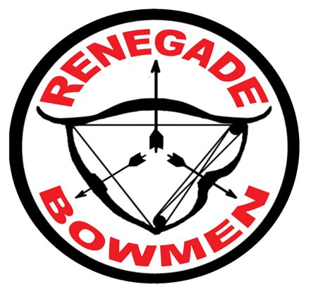
RENEGADE BOWMEN INC
ABN 99411634213
APPLICATION FOR MEMBERSHIP
2025/2026

New Member | Annual Renewal | Past Member
Adult | Junior | Family

Please tick appropriate boxes:

I (Full Name): ABA Number: ABA Expiry:
M/F: Of (Street name): (Town/City): (P/Code):
Mobile Number: Date OF Birth: Occupation:
Email:
do hereby wish to make application for membership of Renegade Bowmen Inc., and if accepted, do undertake to conduct my membership in accordance with the Constitution, Rules and Policies of association of Renegade Bowmen and the Renegade Bowmen Code of Ethics. Additionally. I/we acknowledge that Field Archery and Bowhunting are shooting sports conducted in the natural environment which can impose inherent risks. Consequently, on becoming a member of the Club, I/we accept responsibility for any injury I/we may sustain in such circumstances and acknowledge and waive any right of action against Renegade Bowmen Inc. and its members and absolve Renegade Bowmen and its members from any liability in relation thereto.

Name and phone contacts details to be entered in the Club Phone Book: YES NO

I am / am not a member of another bowhunting or archery club. Please state details:

I certify that the information above is correct.

Applicants Signature: _____________________________ Date: _________

I enclose the required fee of $__________ or deposit to Westpac Bank: BSB# 034189 Acc# 771639 REFERENCE YOUR NAME

I the applicant above also wish to make application for membership of Renegade Bowmen Inc. on behalf of the following persons, who are members of my family and reside at my address: NOTE: Separate single membership must be taken for persons over 18 years.
Full Name of Applicant | Male/Female | ABA Number | Date of Birth | Occupation

I am prepared to accept the responsibility for the above applicants who are under the age of 18 years, until they attain such age.

Signature of parent/guardian: _____________________________ Date: ___________________
The Renegade Bowmen Inc reserve the right to refuse, suspend or terminate the membership of any person whose direct conduct contravenes the Constitution and Rules of the Renegade Bowmen Inc. and the A.B.A Inc.

Please Turn Over for Fees Schedule

ALL MEMBERS OF THE CLUB MUST PAY THE MAINTENANCE LEVY UNLES THE COMMITTEE HAS GRANTED THEM EXEMPTION. (See Note below Table)
 | Existing Members |  |  |  |  |  | Pro Rata Fee Structure for New Applicants Only
 | Without Levy |  |  | Includes Levy |  |  | Includes Levy (Note: not applicable to Junior/Cub Fee)
 | 1 Year | 3 Years | 1 Year |  | 3 years | 01/07 ‐ 30/06 |  | 01/10 ‐ 30/06 | 01/01 ‐ 30/06 | 01/04 ‐ 30/06 | 3 Years
Adult (>17yrs) | $ 50.00 | $ 130.00 | $ 75.00 |  | $ 205.00 | $ 75.00 |  | $ 62.50 | $ 50.00 | $ 37.50 | $ 205.00
Junior/Cub | $ 40.00 | $ 100.00 |  |  |  | $ 40.00 |  | $ 30.00 | $ 20.00 | $ 10.00 | $ 100.00
Family | $ 60.00 | $ 160.00 | $ 85.00 |  | $ 235.00 | $ 85.00 |  | $ 70.00 | $ 55.00 | $ 40.00 | $ 235.00

***It is the responsibility of the Member to make the Committee aware of Voluntary Contribution and therefore the Maintenance Levy waiver.

All members of Renegade Bowmen Inc. are required to be members of the Australian Bowhunters Association Inc. New Applicants are required to attend four (4) coaching clinics, endorsed by the Club coach.
Submit applications to:
In Person: At any club event.
Mail: Membership Secretary, PO Box, 2487 North Ipswich, Qld, 4305
Email: renegadebowmenmembership@gmail.com

